Temasek Polytechnic
School of Informatics and IT

Diploma in Information Technology (IT)

Project Plan

Project Particulars

Tutor | Mdm Ho Li Chin
Class | P01
Project Title | Delonix Regia Hotel Management System

Project Team’s Particulars

Matric Number | Student Name
1400856I | Sim Zhi Yu
1400440B | Li Jin
1405185H | Kimberly Tan Jia Ying

Revision History

Date | Version | Description | Author
09/05/2016 | 1.1 | None | Kimberly Tan
11/05/2016 | 1.2 | Updated Definition and Acronyms | Kimberly Tan
12/05/2016 | 1.3 | Updated Risk Management | Li Jin

Table of Contents

- Introduction
  - Objectives and scope of the project
  - Assumptions and constraints
  - Definitions and acronyms

- Roles and responsibilities

- Estimates and project schedule
  - Work breakdown structure
  - Project schedule
  - Budget summary

- Risk management plan
Project Plan

1 Introduction
1.1 Objectives and scope of the project

The objectives of this project would be to ensure Delonix Regia Hotel improves its services and increases the number of customers coming in. We hope after implementing this online reservation system, we can build relationship with the customers and ensure that they have good user experience. In order to achieve this, the system that we are building have to be easy to learn and use so to ensure user interactions with the system.

The hotel online reservation system will a numbers of features. First would be the rooms feature, which allows users to add new rooms, update room details and browsing through the list of rooms. Secondly, would be the transaction feature which allows us to reserve a room, check in, check out as well as make payment. Third would be the guest feature, which allows us to browse through the guest list and guest rooms. Lastly is the manage user feature, which allows admin to add new user, update user details and showing a list if users.

At the end of this project, this system should help to remove hectic task of customers and executive for searching and booking rooms in this hotel. It would make things more organized as the hotel administrator can store the daily and history record details of the customers in proper database.

1.2 Assumptions and constraints

Constraints | - The project is given eight weeks to complete.  - We are to work within the given budget only.  - Only the group members along with the project manager will be working on this system.  - Only the features written in project scope are to be implemented.  - We are to work within the given budget and resources.
Assumptions | - Management will ensure that project team members are available as needed to complete project tasks and objectives.  - Failure to identify changes to draft deliverables within the time specified in the project timeline will result in project delays.  - All software and hardware are in good condition and is available to work on.  - All team members have the skills required for implementing a system. Such as coding and web design.  - The system should be able to run smoothly by the end of eight weeks.  - The project scope will remain the same. If it changes, we will have to change control approval process.

1.3 Definitions and acronyms
Definition
- Project Manager is an experienced staff assigned by the company to ensure that each member is doing their job.
- The group members include Sim Zhi Yu; the Network Analyst, Li Jin; the Business Analyst and Kimberly Tan Jia Ying; the System Analyst.
- The resources needed for this project is written in the Terms of Reference (TOR)
Acronyms
- MySQL Server: MySQL is the world’s most popular open source database, enabling the cost-effective delivery of reliable, high-performance and scalable Web-based and embedded database applications, including all five of the top five websites.

2 Roles and responsibilities
Members | Features
Sim Zhi Yu | Guest Feature, User Feature
Li Jin | Transaction Feature, User Feature
Kimberly Tan Jia Ying | Rooms Feature, User Feature

3 Estimates and project schedule
3.1 Work breakdown structure
Level 1 | Level 2 | Level 3
1 Reservation System | 1.1 Initiation | 1.1.1 Assign Key Person  1.1.2 Evaluation & Recommendations  1.1.3 Develop Terms of Reference  1.1.4 Submit Terms of Reference  1.1.5 Terms of Reference Approved
1 Reservation System | 1.2 Planning | 1.2.1 Create Preliminary Scope Statement  1.2.2 Project Team Kickoff Meeting  1.2.3 Develop Project Plan  1.2.4 Submit Project Plan  1.2.5 Project Plan Approval
1 Reservation System | 1.3 Requirements Gathering | 1.3.1 Interview users  1.3.2 Draft requirements document  1.3.3 Review requirements document  1.3.4 Revise requirements document  1.3.5 Requirements document approved  1.3.6 Hardware requirements  1.3.7 Software requirements
1 Reservation System | 1.4 Design | 1.4.1 Design user interface  1.4.2 Develop use case diagrams  1.4.3 Revise use case diagrams to more detailed  1.4.4 Develop sequence diagrams  1.4.5 Develop class diagrams  - 1.4.5.1 Database  - 1.4.5.2 Software  1.4.6 Software Design  - 1.4.6.1 Software requirement specification  - 1.4.6.2 Software work package definition  - 1.4.6.3 Software prototype  - 1.4.6.4 Software unit detailed design
1 Reservation System | 1.5 Code Unit and Test | 1.5.1 Build software  - 1.5.1.1 Software unit coding  - 1.5.1.2 Software unit debugging  1.5.2 Perform unit testing  - 1.5.2.1 Plan unit test  - 1.5.2.2 Prepare unit test case  - 1.5.2.3 Conduct unit test  - 1.5.2.4 Records unit test results
1 Reservation System | 1.6 Testing | 1.6.1 Perform integration testing  - 1.6.1.1 Create Test Scenarios  - 1.6.1.2 Peer Review Scenarios  - 1.6.1.3 Conduct integration testing  - 1.6.1.4 Records integration test results  1.6.2 User Acceptance Testing  - 1.6.2.1 Perform user acceptance tests  - 1.6.2.2 Report software bug  - 1.6.2.3 Fixed bug  - 1.6.2.4 User retest  - 1.6.2.5 User confirm test result  - 1.6.2.6 User acceptance test sign-off
1 Reservation System | 1.7 Hardware | 1.7.1 Hardware requirements planning  1.7.2 Hardware system definition  1.7.3 Hardware component selection  1.7.4 Hardware component/unit testing  1.7.5 Software installation  1.7.6 OS installation
1 Reservation System | 1.8 Deployment and Service | 1.8.1 Prepare system manual  1.8.2 System launch
1 Reservation System | 1.9 Wrap up | 1.9.1 Lesson learned  1.9.2 Project closing meeting

3.2 Project Schedule
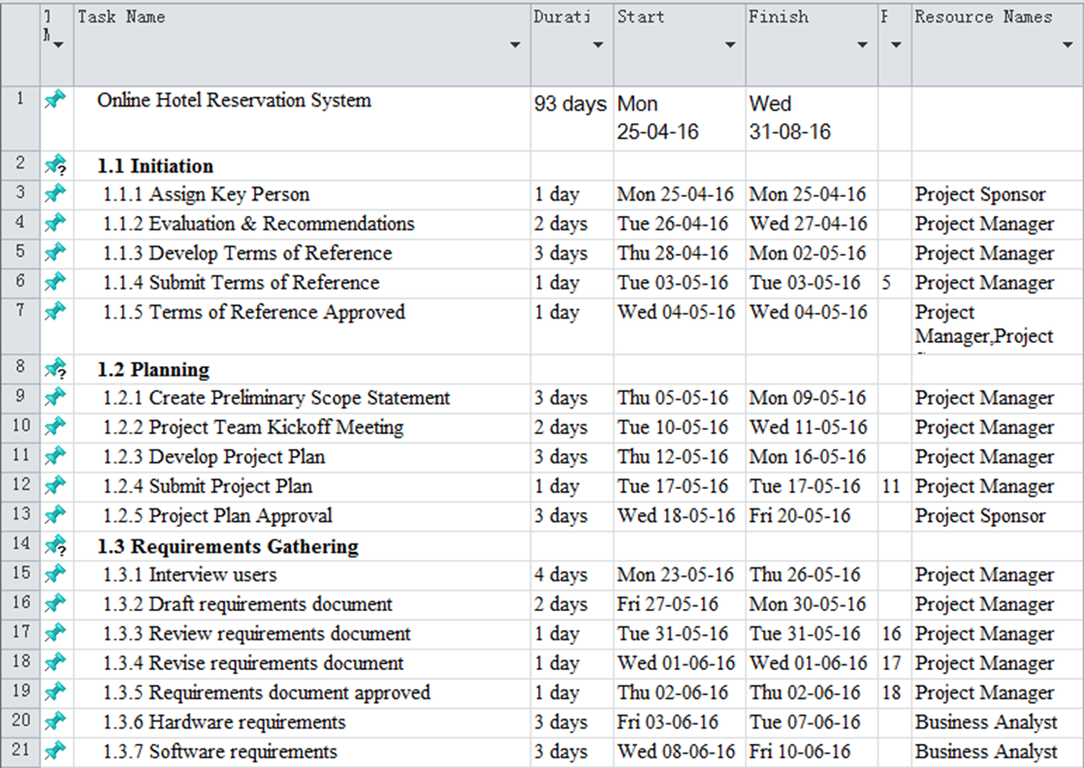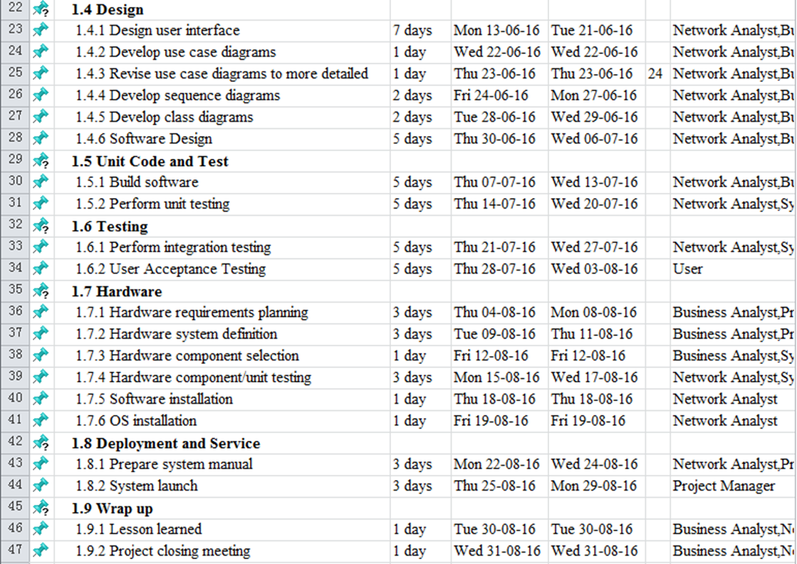
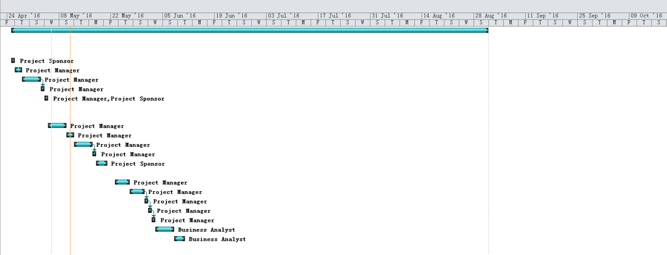
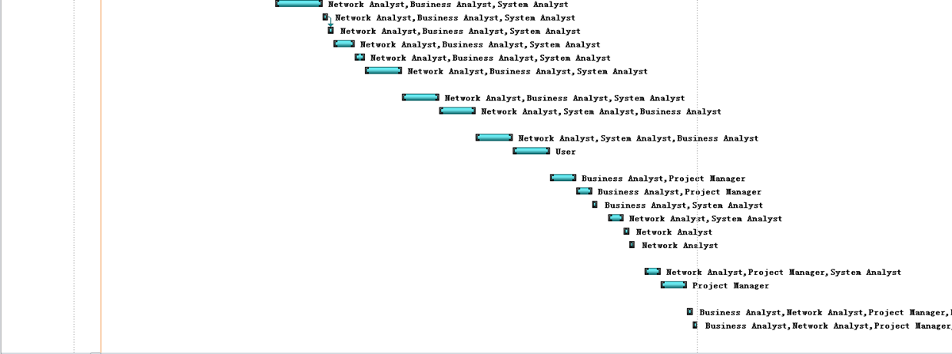

3.3 Budget Summary
Components | Description | Quantity | Price | Total
Computer | - 23” non-touchscreen with 1920 x 1080 resolution  - Intel® Pentium® i3 processor (3M Cache, 3.30 GHz)  - 4GB Dual Channel DDR3 SDRAM at 1600Mhz  - Genuine Windows® 8 Pro x64  - Libre Office (free alternative to Microsoft Office)  - Microsoft Security Essentials Anti-Virus  - Internet Explorer 10  - Mozilla Firefox | 3 | $1,699 | $5,097
Printer | - Print  - Copy  - Scan  - Fax | 1 | $199.99 | $199.99
Telephone | - Built-in speakerphone lets you multitask as you talk.  - 100 name/number phonebook keeps your contacts handy.  - 18-number speed dial for your most frequently dialed or emergency numbers. | 2 | $59.99 | $119.98
Visual Studio | - All standard subscriber benefits including Microsoft software, cloud credits, training, and other resources for developers | 1 | $499 | $499
MySQL Server | - deliver high-performance and scalable Online Transaction Processing (OLTP) applications | 1 | $10,000/year | $10,000
Total |  |  |  | $15,915.97

When we start to develop the system, those hardware and software need to be prepared. We have 3 members in our team, so that we need to purchase 3 computers for each person. We choose this kind of computer because it contains Intel® Pentium® i3 processor and Genuine Windows® 8 Pro x64, so it can provide high performance. The functions of the computer are documented Mr. and Mrs. Wang‘s needs and wrote the coding in the further development. To prepare the printer is used to print any materials and other documents. The telephone is used for internal calls or receiving external calls. We decide to use the visual studio to develop this system, so the license cost is $499 and can be used with 5 members. We will use the local data server to store the information of our customers. This method is more security to keep the information safe.

4 Risk Management Plan
The actions of the risk analysis and management are used to help our team to understand and manage uncertainty. Lots of problems can affect the system. Risk is considered as a probability that some adverse circumstances will actually occur, so that we need to prepare the solution when the risks happen. Risk analysis is done by everyone who is involved in the process of the project.

Risk can be categorized as:
- Financial Risk
- Health Risk
- Security Risk
- Environmental Risk

All in all, a plan is developed to manage whose risks that have high probability and high impact. The risk management contains several stages as followings:

Risk Assessment
Risk Assessment is an important step for us to protect the project and helps us to focus on the risks that really matter. It is considered as the first step in risk management procedure. It helps in identifying the risk and does analysis of the same.

Risk Control
Risk Control is a technique that finds the problem from the risk assessment and implementing changes to reduce risk in these areas. It takes actions to reduce the effect of risk as possible. A mitigation plan should be prepared before taking any risk which may help in the development of the project.

Risk Identification
Risk identification will involve the project team, appropriate stakeholders, and will include an evaluation of environmental factors, organizational culture and the project management plan including the project scope. We need to take attention about the project deliverables, assumptions, constraints, WBS, cost/effort estimates, resource plan, and other key project documents.

There are some types of risk identification in the project:
Risk | Description
User risk | User don’t know how to use the online reservation system or user don’t know English language
Estimation risk | The cost estimated for developing the system may exceed the expectation budget
Software risk | If the platform requirements is not fulfilled then may be the system fail to execute
Business risk | Poor communication between workers and company

Risk Analysis
All risks identified will be assessed to identify the range of possible project outcomes. Qualification will be used to determine which risks are the top risks to pursue and respond to and which risks can be ignored.
Risk | Probability (High/Low) | Effects
User risk | Low | Lack of user knowledge to use the system
Estimation risk | High | Budget not balance
Software risk | High | The system crash or die
Business risk | Low | Mental and health problems

Once this list is created of all risks associated with the project, priorities are assigned to each of the risk, based on the values given to probability of occurring, as well as impact it has on the project if it happens. The highest ranking risks on the list will have a risk mitigation process created, and the lower ranking risks will be dealt with if they occur.

